SLOVAK REPUBLIC

# Name of school: Elementary school, Podporná 10, 820 11 Bratislava

Report card

Name and surname: **Dmitry Ukrainsky**

Date of birth: 20.3.2013

Nationality: Ukrainian

# Place of birth: Odessa

Citizenship: Ukraine Birth number: 130320/1224

Class: VII.A

School year: 2018/2025

# Year: 7.

Class report number: 1

Year of school attendance: 7.

# Level SÿÿR/ÿÿR*): ISCED 2

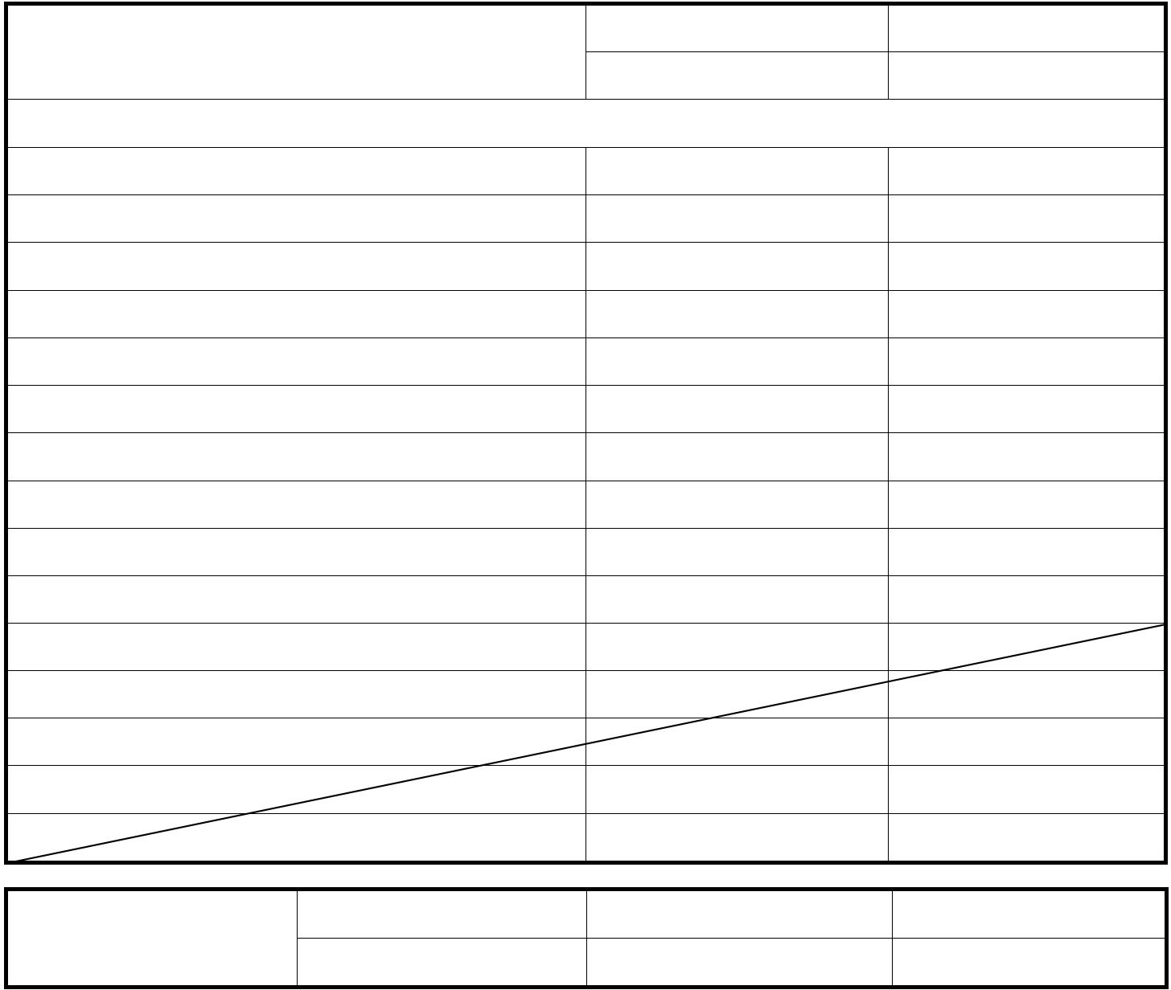

**1st half of the year**

**Second half of the year**

Behavior

**Rating**

**Teaching subjects**

**1st half of the year**

**Second half of the year**

Traveling on a crowded train through Europe under stress

barely survived

managed

loss of loved ones and home

very difficult

managed

courage

uncertainty

managed

foreign language Slovak

you didn't choose it

managed

making new friends

everything from the beginning

managed

subjects in foreign Slovak

unclear

managed

coping with many changes

very difficult

managed

volleyball

he likes it

managed

creating a party

needs

managed

excusable

72

-

Missed childhood lessons

inexcusable

8760

-

*) Level of the Slovak Qualifications Framework / European Qualifications Framework (EQF).

## Rating

1st half year

Dima, on the morning of Wednesday, February 23, 2022, you, as a fourth grader, calmly walked to your school in Dnipro to see your friends and teachers. You had no idea that it would be the last time. On Thursday morning, you didn't come to school anymore, the war began.

You saw your classmates a few more times online, and in March you had to leave in a hurry without preparation and without having time to pack the necessary things. You didn't know where you were going, when you would arrive, or what was even happening. You sat with your mother on a crowded train, where you couldn't breathe properly, everyone was pushing each other. You traveled for hours into the unknown - 2,134 km to be exact. You arrived in Lviv, where there were probably a million people. You had to change to another train, even more crowded. The train stood at the Polish border for over four hours. It felt like an

eternity, the uncertainty of what was happening. You arrived in Poland, spent the night there, in a foreign country, but the stress subsided a little. The next day you traveled to Slovakia, but thanks to the confusion, you ended up in Prague.

Finally, you arrived in Bratislava. Everything was in chaos. You discovered a huge world outside your home, but you didn't choose it. You and your mother ran away into the unknown. It wasn't an adventurous journey, nor a vacation, nor a trip. It was a dangerous escape with a single suitcase containing only the most necessary things. And as a welcome to a safe country, you had to adapt as quickly as possible and become a Slovak student. Get used to all the changes and the new system. Study at school as if nothing had happened. No one came to tell you: "Dima, how did you manage it? What do you need? How can I help you cope with all that stress?"

II. Half year

You entered the first school, luckily there were a few Ukrainian kids there. They were all confused. You didn't know how long it would take.

How long will you live here? Will you make any friends here? Some stayed in Dnipro on the Internet. Since September you have been transferred to a state school. Mostly Slovak children and Slovak teachers. You managed to get into a school where you had to start all over again.

But you didn't want a new school and learning Slovak, you wanted to go back home. You had to listen, count, and learn new words, even though you so desperately wanted to hear your own words at your school in Dnipro. You wanted to run out into the hallway and run to your friends to share your experiences with the fourth-graders in Dnipro, but instead you stood silently in your fifth-grade classroom. Alone among strangers.

Dima, you finally made it through. It was very difficult, it cost you so many tears, so many headaches and stomachaches, so many dark days when the sun didn't shine. You managed to be strong, to be silent and not shout, to endure injustice, rejection, non-acceptance and so many losses. You wanted so much to hear in Ukrainian that someone from your teachers and classmates would understand you. But it didn't happen. But today you can speak your mind, be more independent, you have built completely new friendships, you have learned a new language that you didn't want to learn. You are brave

and strong. But inside you know you're tired of it. You deserve to stop and turn back time. So you can scream: "I can't anymore!". "I don't want to!" "I'm angry!" "Leave me alone!" Today you don't have to be strong, brave, alert and tense.

You can relax carefully. You have done nothing wrong and in no way have you ever deserved such a difficult fate. You did not deserve that people sometimes do not understand you and do not understand you. On the contrary, you deserve a medal. A skyscraper could be built on your heroism and strength.

Right now you deserve a vacation. You deserve to be yourself. And maybe you will gradually see that there are many good people around you, even Slovaks. Maybe you will already see that you are stronger and people can be nice too. Young Ukrainian hero – Dmitry - thank you for what you are...

## Overall rating

**1st half of the year**

survived

**Second half of the year**

passed with honors

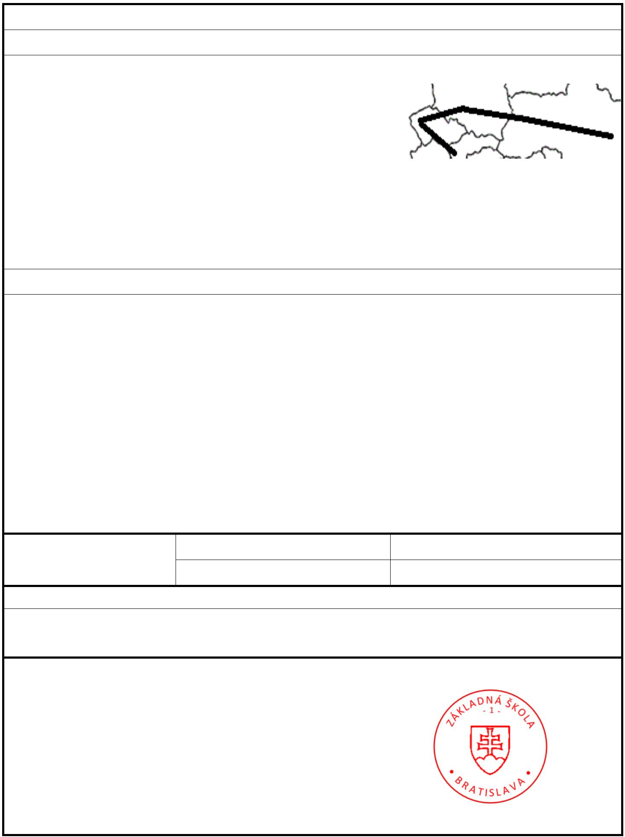

**Clause**

The student has overcome many life challenges.

The student has gone through the compulsory school of life.

QR code

In Bratislava

date 12.5.2025

...........................................

class teacher

...........................................

school principal